**Orion – Greek Mythology and Aboriginal Connections**

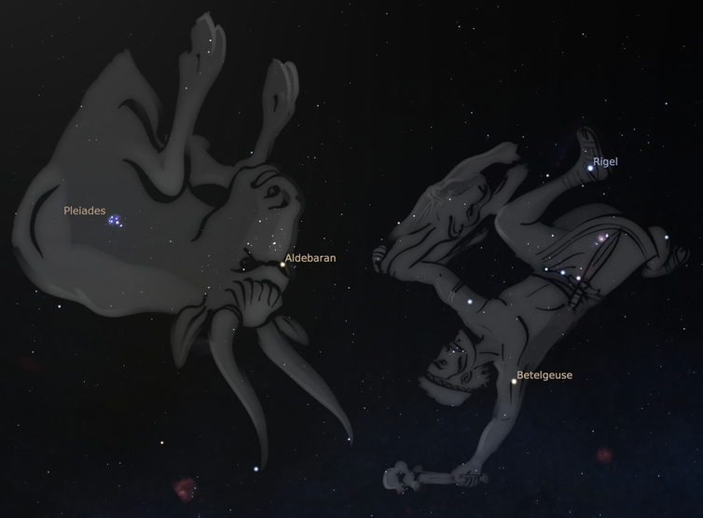

In Greek mythology, Orion was an excellent, yet boastful hunter who was eventually killed by a giant scorpion (the zodiac sign Scorpio). The gods placed the two on opposite sides of the sky to separate them but each night they chase each other across the sky. Orion is seen locked in a constant battle against a charging bull (the zodiac sign Taurus). In some representations, he wields the pelt of a lion and a club, in others, a sword and shield, or a bow and arrow.

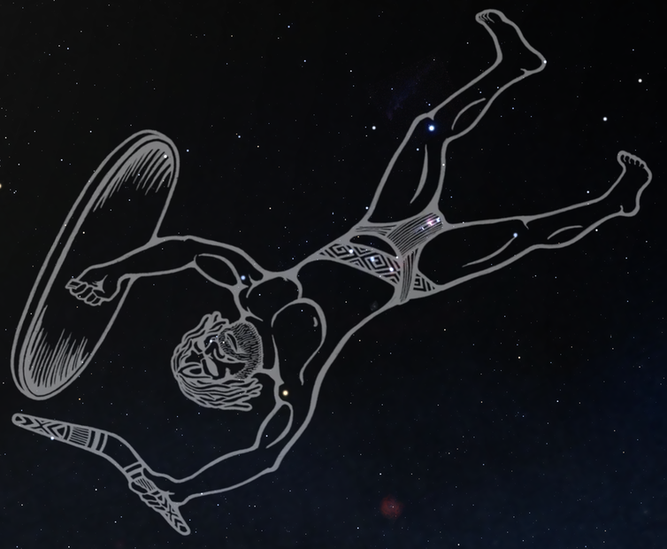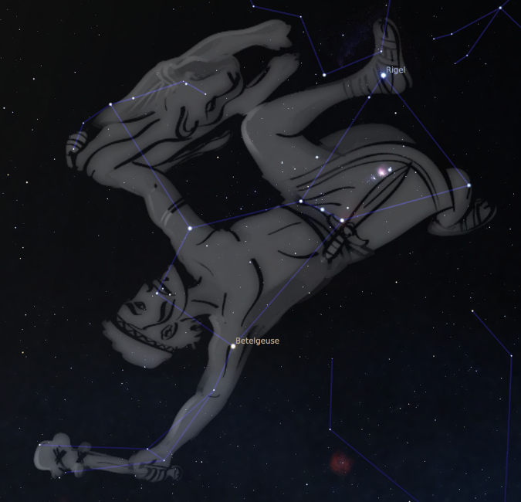

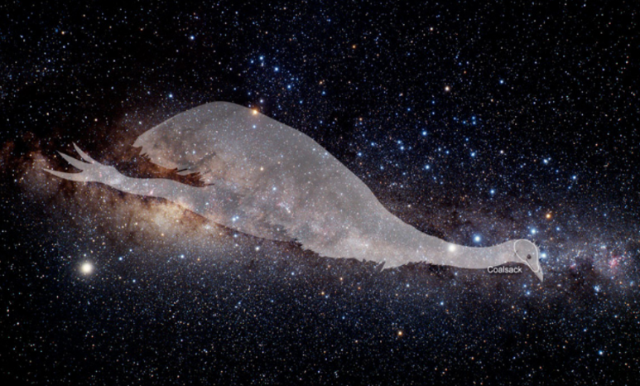There are great parallels between Greek and Aboriginal cultural interpretations of the stars considering the two arose on opposite sides of the world with no contact since their origins in Africa. In Aboriginal [Wiradjuri](https://en.wikipedia.org/wiki/Wiradjuri) cultures from south-east Australia, this cluster of stars is known as Baiame, the creator god and Sky Father in the dreaming. Here, he wields a boomerang and shield (upper-right). It is said that he hunts and chases the emu that appears in the haze of the Milky Way (right), but each night trips and falls over the horizon as the constellation sets, which is why he appears upside down.

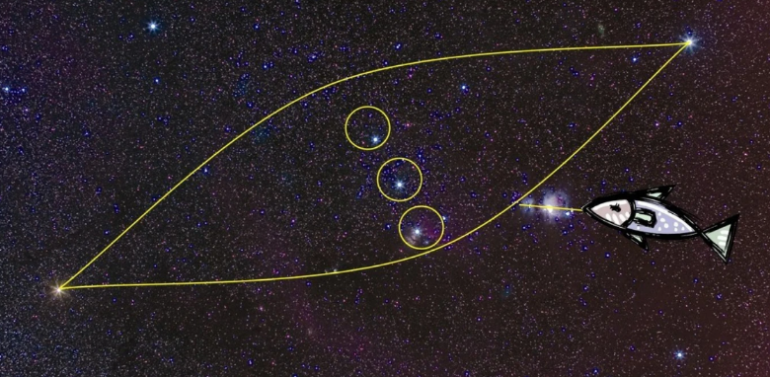When seen from an Australian vantage point, Orion is upside down, so the Yolngu people of north-eastern Arnhem Land saw three brothers and a canoe. They called this Djulpan, which is a prominent Aboriginal legend.

One day, three brothers decided to go fishing against the advice of their elders. It was storm season and far too dangerous. The three brothers ignored the warning and went anyway. They found themselves sitting in a canoe for hours catching nothing but kingfish, which is a problem as it's the totemic animal for their tribe. To eat it would be akin to cannibalism.

Eventually one of the brothers cracked and ate one, causing Walu, the Sun Woman, to become furious. Walu took the storm clouds and turned them into a whirlwind that lifted the boat up and cast the brothers into the sky where they remain today.

This story is an excellent example of the moral lessons engrained in astronomy storytelling. There's both a lesson about keeping sacred law, and paying heed to the words of elders. Not only that, but there's also a practical application. Djulpan is only visible from February to March, which is when the monsoon begins. That tells you it's no longer safe to go out and fish.

As there are many Aboriginal cultures, there are many more interpretations of various star clusters. Below are just a few examples.

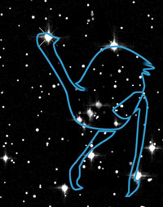

Orion representing an emu seen from a Southern hemisphere perspective (left) and orientated correctly for the image (right).

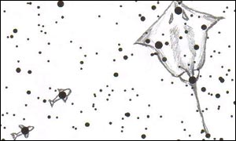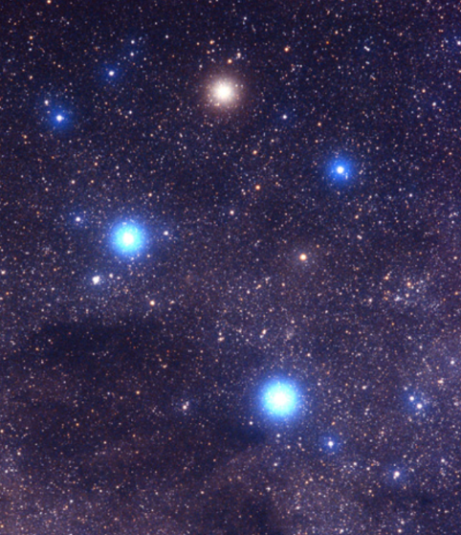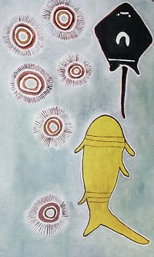In Arnhem Land, the Southern Cross is a shark chasing a stingray and the two pointer stars are smaller fish.

But for another group of Aboriginal people, it is a white ghost gum with two yellow-crested cockatoos.